Final Fantasy III DS Speedrun Route

Category: Any% (Glitches) (English Version)

**Disclaimer by Eltherian (redacted to fit current state of the route):**

**The route is mostly complete! The only thing left is to test, optimize and improve it where possible. Barring major glitches being discovered for the DS version or the PC version, this is the fastest way to beat the game (in a RTA/SS run).**

# **Notation**

A **chapter** (in this document) is, normally a complete dungeon or town, which in this guide, is comprised of sub-chapters.

A **sub-chapter** is usually a zone, floor or section of the game comprised of different steps (identified by the indented numbering list 1., 2., and so on).

**Steps** are actions that you should perform sequentially to optimize your time. Some stepsoccasionally have different levels of numbering lists (identified by the indented a., b., and so on), which provide small complementary tips to very specific situations that are mostly RNG dependent.

In general we use directions such as **north, south, east and west** when referring to top, left, down, right because in certain situations you must go in corner directions.

When we change jobs, we decided to write all for jobs separated by a dash (-). The first “slot” is Luneth’s job, the second is Arc’s, the third is Refia’s and the last on is Ingus’. It is advised to stick with the recommended jobs and not change it much.

Acronyms:

**RNG**: It means “Random Number Generator” and it is the thing that decides when you’ll get into battles and when you get item drops and such. It is bery little you can do about this.

**SAI**: In this document, it means “Strongest Attacking Item”. The reason we use it is because you can get item drops that are stronger than what you’d normally have. Check the list of attacking items at the end of the guide for reference.

“**X**” and “**0**”: Both of these represent chests and forms an image of how the chests are scattered in game. The X’es are the items you should pick up, while the 0’es are those you should ignore.

# **Pre-Game / RNG setup**

# There is no specific thing to do here, as we do not have many good routes yet, and what you have to do is dependent on which system you play on. If you know what to do, then do it. If not, then read this for more info: <http://pastebin.com/i7wt5hqb>

If you don’t bother with RNG manipulation, or just want to start your run, then skip this;

# **Altar Cave**

## Floor 3

1. Pick the chest on the right for a Potion;
   1. If you get a Potion or a Phoenix Down as an item drop after (or in) the 1st tutorial battle, you may **skip** this chest;
2. Do not duplicate the Potion, you only want one;

## Floor 4

1. Pick the chest on the lower left corner of the map (contains **Antarctic Wind**);
2. Set Luneth to the **Rear** line and customize your **Config**;
3. Proceed to **northwest**;
   1. Kill any monsters you find;

## Floor 5

|  |  |
| --- | --- |
| Boss: Land Turtle | |
| HP: | 111 |
| Strategy: | 3 casts of Antarctic Wind kills it.  Duplicate the one gotten in the chest.  Note: Use Potion if you have to. |

# **Ur Village**

1. Enter house on the left;
2. Enter back room and talk to the Elder;
3. Talk to the old man outside the house and give him your **only** Potion (he gives you a **Phoenix Down)**;
   1. If you got a lucky Phoenix Down drop at some point, **skip** talking to the old man;
4. Go to the pond in the back of the village, watch the cutscene;
5. Exit Ur and go south;

# **Kazus**

1. Talk to Arc;
2. Go to the Inn and talk to Cid;
3. Leave the town and go to the airship (in case you can’t remember it’s on the desert next to Kazus) to get Refia;
4. Go **northwest** to Castle Sasune;

# **Castle Sasune**

1. Talk to Ingus;
2. Go to second floor of the main castle;
3. Talk to the King;
4. Leave Castle Sasune, head **northeast** to Sealed Cave;

# **Sealed Cave**

1. Fight all battles here;
   1. Duplicate Antarctic Winds (spam them against enemies);
   2. Duplicate 20 Phoenix Downs (this should be enough for the rest of the game);

## Floor 1

1. Follow main path, go up and open chest **(Cure) –** equip and heal if you need to;
2. Move everyone to the **rear** line;
   1. You can also do this at the start of the dungeon to be super safe, though it’s faster to just take advantage of the fact that we are already opening the menu to heal to do this as well;
3. Go down, right at the fork and follow until next fork;
4. At the second fork go right to floor 2;

## Floor 2

1. Press skull in the top right corner to proceed to floor 3;

## Floor 3

1. Go up at the first fork;
2. Skip this chest and go left;
   1. DO NOT GO DOWN IN THE LARGE AREA;

|  |  |
| --- | --- |
| Boss: Djinn | |
| HP: | 600 |
| Strategy: | Spam Arctic/Antarctic Wind, make sure to dupe them.  Should die in 2-3 hits. |

Watch the cutscenes with the crystal.

# Return to Castle Sasune

1. Watch cutscene lifting curse;
2. Go back to Kazus;

# Return to Kazus

1. Go to the Inn, talk to Cid;
2. Go to Refia’s House and watch the scene;
3. Buy **4 Mythril Bracelets;**
4. Leave Kazus and board the airship;
5. Destroy rock to the **west**;
   1. Note that your cursor in battle will be reset after this
6. Head **south** and enter Canaan;

# Canaan

1. Go to Salina’s house and talk to her. Find the **Mallet;**
2. Exit, then enter the Magic Shop and buy 3 **Cure** and **4 Thunder;**
3. Go to the top of the town, follow the river way south and get **Elixir** on the chest**;**
4. **CLASS CHANGE:**
   1. White Mage - Red Mage - Red Mage - Red Mage;
   2. *Note*: We use 1 White Mage because we want to abuse the fact that White Mages can use Teleport sooner;
5. Put the Elixir and Mallet on the top menu to duplicate in your next battles;
   1. You should have at least 2 spare Antarctic Winds, which means you can dupe the Mallets and Elixirs in one battle.
   2. You need exactly 16 Mallets and 25 Elixirs
6. Leave, go to Dragon’s Peak;

# **Dragon’s Peak**

1. Take left path and go up to trigger a cutscene;
2. Run from Bahamut;
   1. You’ll get healed after the battle;
3. Head **south** and 1 Mallet on every character;
4. Enter Tozus;
   1. It’s on the southern forest a little bit to the left, it might be hard to find if you don’t know where it is;

# **Tozus**

1. Enter the Inn shop in the **south** part of town, buy **11 Eye Drops** and **11 Antidotes**;
2. Go to **northwest** part of town and enter the Doctor’s house;
   1. Grab the **Cura** from the pot;
   2. Heal the doctor with Antidote and enter the Tozus tunnel;

# **Tozus Tunnel**

1. Grab first two chests for **2 Phoenix Downs**;
2. Follow the tunnel and exit;
3. Enter Viking’s Cove;

# **Viking’s Cove**

1. Head **north** through the door and go to the right;
2. Head **south** after the Moogle and speak to the Viking Leader;
3. Exit Viking Cove to the **north** and, whatever you do, **DO NOT ENTER THE SHIP;**
4. Walk **north** along the peninsula until you reach the Nepto Temple;

# **Nepto Temple**

1. Head north, talk to the dragon statue;
2. Enter the dragon statue;
   1. Kill the enemies
3. Enter the second hole, skip the chest and head down the corridor;

|  |  |
| --- | --- |
| Boss: Giant Rat | |
| HP: | 900 |
| Strategy: | Item nuke to oblivion.  The rat has no elemental weaknesses.  If Desch attacks, you will one-cycle him.  Note: Pay attention if the rat drops a Tranquilizer or not. |

1. Walk back to the entrance;
2. Use 4 Mallets to de-mini the party;
   1. Doesn’t have to do de-mini here, but should be done eventually;
3. Place Nepto Eye in the dragon statue;
4. Return to Viking’s Cove and talk to the leader;
5. Enter the Enterprise ship and sail to Tokkul;
   1. It’s **southwest** of Nepto Temple;
   2. If the Giant Rat dropped a **Tranquilizer** **skip** Tokkul and go straight to the Village of the Ancients;

# **Tokkul**

1. Pick up **Lamia Scale** and leave;
2. Duplicate 81 Lamia Scales (or Tranquilizers);
   1. This gives you nearly enough money for the entire game;
   2. You need to do this to the Tranquilizer as well, you just don’t need to visit Tokkul and pick a Lamia Scale if you have a Tranquilizer;

# **Village of the Ancients**

1. Head directly north and sell **ALL Lamia Scales/Tranquilizers and a couple of Antarctic Winds**;
2. Buy **3** **Teleport, 3 Cura and 1 Thundara** in the Magic Shop;
3. Buy **4 Flame Mails;**
4. Teleport out if you can and head **east** to the Chocobo Woods;
   1. Take this chance to equip Teleport, Thundara and optimize your party’s gear;
   2. When riding Chocobos you won’t get any encounters so run straight for your ship;
5. Sail **northwest** to Castle Argus;

# **Castle Argus**

Skip this if you already have an Arctic Wind;

1. Go to the top floor of the castle where there is the King’s table;
2. Enter secret passage to the right of the chests and get **Arctic Wind**;
3. Teleport out of Castle Argus and head **northwest** to Gulgan Gulch;

# **Gulgan Gulch**

1. Head **south** to the second floor and talk to the man in the middle;
2. Go further in and pick up the **Mage Robe**, **Ice Staff** and **Fire Staff**;
3. Change your White Mage into a Red Mage;
4. Teleport out and go **north** to Chocobo Woods, then go **northeast** to Tower of Owen;

# **Tower of Owen**

1. Use Toad on entire party when you stand in front of the hole to Floor 2;

## Floor 2

1. Un-toad party and turn Luneth into a Red Mage;
2. It’s pretty straightforward;

## Floor 3

1. **Optional**: Get chest for some **Echo Herbs;**
   1. We only pick these Echo Herbs in case all of our party gets silenced and we can’t cast Cure;

## Floor 4

1. Head **east** then south to Floor 5;

## Floor 5

1. Head **south** and **west** to Floor 6;

## Floor 6

1. Head all the way left for a cutscene, then press the switch in the upper middle of the room;
2. Proceed to Floor 7;

## Floor 7

1. Follow path to Floor 8;

## Floor 8

1. Go left to reach Floor 9;

## Floor 9

1. Go nothing but **west** to Floor 10;

## Floor 10

1. Go **west** then **south** and head to the **southeast** part of the room for Floor 11;

## Floor 11

|  |  |
| --- | --- |
| Boss: Medusa | |
| HP: | 3,000 |
| Strategy: | Arctic Wind in to submission.  Should be done in 5-6 hits.  She doesn’t deal a lot of damage so healing should not be needed. |

1. Proceed **north** out of the maelstrom and then **west** to the Dwarven Hollows;

# **Dwarven Hollows**

1. Proceed to second floor;
2. Go to top right to the armor shop;
3. Buy **3 Mage Robes, 4 Ice Shields and 4 Ice Helms**;
4. Go to the middle of the second floor and talk to the dwarf;
5. Optimize your equipment and turn your party into Toads;
6. Go **west** and enter the Subterranean Lake;

# **Subterranean Lake**

1. The lake is fairly linear, **skip** all the chests on the first two floors, and get the two on the third floor for **6000 gil**;
   1. It is possible that some enemies petrify you so you can pick up one of the multiple **Gold Needles** along the way;
   2. Kill all the enemies

|  |  |
| --- | --- |
| Boss: Gutsco | |
| HP: | 3,500 |
| Strategy: | Arctic Winds. Takes 2 turns.  Note: Bomb Arm’s may kill him faster. |

1. Teleport out and talk to the dwarf at the shrine again;
2. Watch the cutscene;
3. Leave the Dwarven Hollow, proceed north to Molten Cave;

# **Molten Cave**

## Floor 1

1. Go **southwest** through lava to Floor 2;

## Floor 2

1. Follow the lava path and head directly **west** for Floor 3;

## Floor 3

1. Go **north** in lava to hit switch right of chest;
2. Proceed to Floor 4;

## Floor 4

1. Do your final preparations;
2. Healing;

## Floor 5

|  |  |
| --- | --- |
| Boss: Salamander | |
| HP: | 5,700 |
| Strategy: | Spam some more Arctic Winds.  He should be dead in 5 hits. |

1. Teleport to the world map;
2. Return to Dwarven Hollows;

# **Return to Dwarven Hollows**

1. Talk to Dwarf in the middle again and get **Magic Key;**
2. [Sauce](http://www.gamefaqs.com/ds/924897-final-fantasy-iii/faqs/59886) – Treasury Map;
   1. Items are listed from left to right, top to bottom;
   2. Get **Gauntlets, Heroic Shield, Scholar Hat, Scholar Robe, Book of Fire/Ice/Light, Ottershroom, Knight Armor and Phoenix Down;**
   3. XX0XXXXX | X = Open this chest

000XXXX0 | 0 = Do not open this chest

1. **CLASS CHANGE:**
   1. Red Mage – Knight/Scholar – Scholar - Scholar;
   2. Setting a Knight is optional, but it gives you more HP;
2. Teleport out of Dwarven Hollows;
3. **Re-enter to trigger a cutscene**;
4. Sail to Tokkul;
   1. While sailing to Tokkul when you get in what you expect to be your last fight let your Scholars kill themselves while the Red Mage guards;
   2. On the second turn, have your Red Mage cast Thundara so you can safely end the fight;
   3. After the battle, revive your Scholars, but keep them at critical HP;

# **Returning (or not) to Tokkul**

1. Upon entering, a cutscene will play and the party is taken to Castle Hein;

# **Castle Hein**

## Floor 1

1. Go through next wall;
   1. **Do not heal**, you want your Scholars at critical HP always;
2. Cast mini on your party;
3. Leave through the hole in the wall;

## Floor 2

1. De-mini your party;
2. Change Red Mage to Knight;
3. Follow path to open area, go **west** to next part of the floor;
4. Proceed to Floor 3 in the **northwest** part of the area;

## Floor 3

1. Avoid the first three doors of the area;
2. Go **north** to Floor 4;

## Floor 4

1. Go **west** then **northwest** to go to Floor 5;

## Floor 5

1. Follow path to Floor 6, skipping the chest;

## Floor 6

1. Go to **northwest** portion of the floor to go to Floor 7;

## Floor 7

|  |  |  |  |  |
| --- | --- | --- | --- | --- |
| Boss: Hein | | | | |
| HP: | 4,500 | | | |
| Job set: | Knight | Knight/Scholar | Scholar | Scholar |
| Strategy: | **Bomb Arms** are very helpful here, although not completely necessary.  First round: spam Arctim Winds.  Second round: spam Bomb Arms.  Usually results in a 1-2 cycle.  You should only have 1 Book per Scholar, otherwise they can kill themselves while confused. | | | |

1. After the fight, you will be taken to the Living Woods;
2. Go to your ship and go to Castle Argus;

# **Returning to Castle Argus**

1. Head to top floor and talk to the King;
2. Turn your Knight in to a White Mage;
3. Teleport out and head to Canaan;

# **Returning to Canaan**

1. Go to Cid’s house and talk to Cid;
2. Watch the cutscene;
3. Teleport out and fly to Gysahl;

# **Gysahl**

1. Pick up Shuriken;
2. Sell Shuriken;
   1. You can sell your Leather Armor, Vest, Knives and Staves so you can navigate better between your items;
3. Buy **2 Magic Keys**;
4. Teleport out and fly to the Surface World;
5. Enter the Wrecked Ship;

# **Wrecked Ship**

1. Proceed to second floor by walking to the left and between the inverted arches;
2. Go to the third floor via stairs;
3. Talk to the old man, give Aria an **Antidote, Elixir, Potion** or **Hi-Potion**;
4. Teleport out and fly south to the largest island and enter the Temple of Water;

# **Temple of Water**

1. Get crystal shard in back of the temple;
2. Teleport out of the temple and go to the Cave of Tides;
3. Change your jobs back;
   1. Knight – Scholar – Scholar - Scholar;

# **Cave of Tides**

**WARNING:** Kraken is a RNG dependent fight so I strongly advise to save before doing the dungeon.

1. Kill every enemy
   1. Ropers might drop a **Turtle Shell** so pay attention to that;

## Floor 1

1. Follow paths to Floor 2;

## Floor 2

1. Cross bridges to get to a fork between two bridges;
2. Take the **SECOND** of the two bridges to advance to Floor 3;

## Floor 3

1. Take the lower bridge to continue to Floor 4;

## Floor 4

1. Advance to Floor 5;

## Floor 5

1. Make sure everyone is at full HP for the fight, or else Kraken will wipe you with Blizzara, if using Knight, he should have the **Flame Mail** equipped as it halves ice elemental damage;
   1. There is a very low chance, but it is possible that Kraken casts Blizzara in twice in a row, if he does, you better have saved before;
   2. Optional class change: 4 x Schoolars. It is safer, but considerably slower as you need to change it back after the battle.

|  |  |  |  |  |
| --- | --- | --- | --- | --- |
| Boss: Kraken | | | | |
| HP: | 8,000 | | | |
| Job set: | Knight/Scholar | Scholar | Scholar | Scholar |
| Strategy: | Nuke with Arctic Wind.  Takes about 5 or 6 Arctic Winds to kill it.  The Knight can either use Phoenix Downs or Elixirs, it’s all up to luck what happens here. | | | |

# **Amur Village**

1. Buy **2 Heroic Shields, 3 Black Belt Gi’s,** and **3 Chakra Bands**;
2. Talk to the girl **south** of armor shop;
3. Talk to the old man in house **east** of weapons shop;
4. Use the canal to head to Amur Sewers;

# **Amur Sewers**

1. Try to get your Scholars at critical HP so the Knight can be used as a sponge;
   1. Either kill them yourself or keep running away relying on RNG;

## Floor 1

1. Go **east** to Floor 2;

## Floor 2

1. Go **west** to Floor 3;

## Floor 3

1. Fight the toad minibosses;
2. Proceed to Floor 4;

## Floor 4

1. Go over the small bridge and go into the hidden passage into a new room;
   1. While there, go to the other platform and pick up the **Power Bracers** (for you Knight), and go back to Floor 4;
2. Proceed to Floor 5;

## Floor 5

1. Teleport out after watching cutscene;

# **World Map**

1. Some enemies can easily destroy your party here, you should save here because of that;
2. Go **east** (to the right), along the river, then right before it ends, go **south** downwards in to a Chocobo Forest;
3. Catch a Chocobo and go to the Goldor Manor;

# **Goldor Manor**

## Floor 1

1. Enter the top right room, proceed to Floor 2;
   1. Use a Magic Key;

## Floor 2

1. Follow pathway to Floor 3;

## Floor 3

1. Take **southern** pathway for short way to Floor 4;

## Floor 4

1. Have your Scholars at critical HP if using a Knight, if not – heal them before battle;

|  |  |  |  |  |
| --- | --- | --- | --- | --- |
| Boss: Goldor | | | | |
| HP: | 9,000 | | | |
| Job set: | Knight/Scholar | Scholar | Scholar | Scholar |
| Strategy: | Goldor has high Magic Defense, so this will take a few turns. You can use 4 Scholars if you got a Bomb Arm drop.  Note: As mentioned before it can surprise you with Thundara, but very rarely.  Spam your SAI against him (it can either be Arctic Wind or Bomb Arm).  Knight should use SAI until he needs to heal with Elixir.  Use Study when Goldor protects himself. | | | |

1. Turn your Knight into a Scholar and use Ottershroom to Teleport out. Free your ship and head to Duster Village in the middle of the map;

# **Duster Village**

1. Go directly **north** of weapon shop, following the river shore;
2. Search the top left corner near a bard to get **Earthen Drums;**
   1. You can also pick up the one at the right corner
3. Buy a **Madhura Harp;**
4. Buy **4 x Rune Bracers** and **4 x Feathered Hats**;
5. Leave and go to Castle Saronia;

# **Castle Saronia**

1. Go to **Southwest District;**
2. Put Earthen Drums at the top of your inventory for the next fight;
   1. If you only picked up 1 at Duster Village
3. Enter Tavern in the **north** part of town;
   1. The fight should be over in one Earthen Drum attack;
4. Leave after the battle;
5. Enter Castle Saronia and watch the cutscene;
   1. **Warning:** Garuda is the most RNG dependent boss in the whole game, saving before entering Castle Saronia is strongly advised;
   2. Make sure your 4th Scholar is not in the job penalty stage;

|  |  |  |  |  |
| --- | --- | --- | --- | --- |
| Boss: Garuda | | | | |
| HP: | 10,000 | | | |
| Job Set: | Scholar | Scholar | Scholar | Scholar |
| Strategy: | Spam Arctic Winds.  Will take 4-5 Arctic Winds / SAI to finish him off.  Lightning may kill characters.  Note: Bomb Arms should guarantee the one-cycle if no one dies. | | | |

1. Go to the secret passageway to the right and pick up the **Tome of Ice, Tome of Fire** and **Tome of Light**;

000

00**X** | X = Open this chest

**X**00 | 0 = Do not open this chest

00**X**

1. Go to the outside floor and enter the building on the right;
2. Talk to any of the engineers;
3. Leave and fly to **Northeast** Saronia and go into the **Northeast** weapon shop and buy **2 Rune Staffs**
4. Leave and fly to Reptilo Village;
   1. **Northwest** most point on the map;

# **Reptilo Village**

1. Search tree left of the Moogle for **Turtle Shell;**
   1. At some point before World of Darkness, you need to duplicate at least 13 Turtle Shells
   2. As mentioned before it is possible that a Roper dropped it, if he did **skip** this;
2. Buy **7 Ottershrooms** in the Inn shop;
   1. From this point on, you’ll use Ottershrooms to teleport out if less a scholar can teleport out;
3. Teleport out and go to Doga’s Manor;

# **Doga’s Manor**

1. Watch the scene and the proceed further in to the manor;
2. Go to the shop area room;
3. Buy **Curaga;**
4. Enter the office and press the candle switch;
5. Advance through the passage to the right;
6. Mini your party with Mallets and enter the hole;

## **Cave of the Circle**

1. Follow the linear path to the end of the cave;
   1. Should not fight enemies;
2. De-mini your party with your last Mallets;
3. 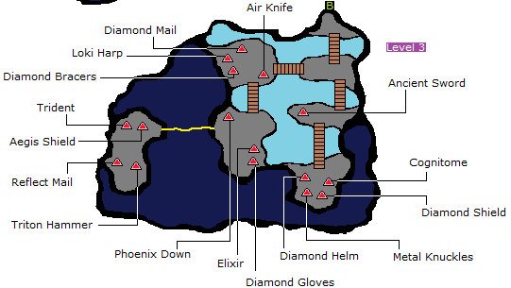Fly to the Sunken Cave;

# **Sunken Cave**

1. **Class Change:**
   1. Scholar – Knight – Knight – Knight
2. Go to Floor/ Level 3 and pick up:
   1. **Diamond Helm, Diamond Shield Cognitome, Diamond Mail, Diamond Bracers, Diamond Gloves** and **Aegis Shield**
   2. To kill the skeletal dragon that’s guarding Aegis Shield simply use an Elixir on him;
3. The monsters here give insane amounts of EXP, so kill all of those who are vulnerable to ground;
   1. Dozmares, the flying griffons, are immune to ground;
4. Teleport out and fly to the Temple of Time;

# **Temple of Time**

**Warning:** Given it is extremely likely to die in this dungeon (back attacks), it is advised to save before doing this dungeon;

*Note: Keep everyone at full health with cure as much as you can, use Elixirs if you absolutely have to;*

## Floor 1

1. Overall strategy:
   1. Duplicate Earthen Drum during battles;
   2. **Optional**: Have some Knights on the front line so that if you get back attacked the damage is reduced;
   3. Avoid any flying creature;
   4. If you get in to a fight with a Dragon, Behemoth, or other flying enemies – **RUN;**
2. Go up through water to get to Floor 2;

## Floor 2

1. Advance to Floor 3;

## Floor 3

1. Go to upper right stairs in water to get to Floor 4;

## Floor 4

1. Enter the secret passage in the top right portion of the room, get the middle chest for the **Protect Ring** and the right chest for the **Lamia Harp;**
2. Give the Protect Ring to the Scholar;
   1. It is extremely important because it boosts speed and halves all elemental damage;
3. Go back to the entrance of this floor, go down the stairs and right to get **Noah’s Flute**;
4. Teleport out and fly to Unei’s Cave;

# **Unei’s Cave**

1. Talk to Unei to wake her up;
2. Fly to the Ancient Ruins;
   1. Located **west** of Saronia through the mountains;

# **Ancient Ruins**

## Floor 1

1. Watch Unei destroy the rocks;
2. Proceed to Floor 2;
   1. **Skip** the first door;

## Floor 2

1. Go to Floor 3;

## Floor 3

1. Pick up the **Faerie Claws** in the **northeast** room;
2. Go to Floor 4 In top middle of the room;

## Floor 4-7

1. Very linear, just follow paths to the end;

# **Invincible**

1. After getting the Invincible buy **Curaja**, **4 White Robes**, **3 Diamond Bracers** and **2 Diamond Gloves;**
   1. If you still have gil, you can use it on: **2 Diamond Shields**, **Diamond Armor**,and **Diamond Helmet**(in that order);
2. Go to **Bahamut’s Lair**

# **Bahamut’s Lair**

## Floor 1

1. Go **South** and proceed to Floor 2;

## Floor 2

1. Relatively linear, pick up **Chocobo’s Wrath** and **Turtle Shell,** before going to Floor 3

## Floor 3

1. Grind against all the enemies you find here until you reach 1000 HP with your Knights. Your Scholar should use Chocobo’s Wrath/ Earthen Drum, dependent if you’re battling 1 or more enemies, the Knights should always use Chocobo’s Wrath;
2. Teleport out and fly to the Nautilus;
3. Dive into the top of the Crystal Tower continent;
   1. While underwater, go under the mountains right in front of the Ancient’s Maze. Emerge there and land on the mountain so you can freely go in and out of bounds;
      1. Kill all enemies you encounter underwater;
   2. Warning: Your run will end if you mess up here, save if you are not confident before attempting this trick!
4. Enter the **Ancient’s Maze**;

# **Ancient’s Maze 1**

1. Go directly **North** and fight the boss, using 4 Scholars;

|  |  |  |  |  |  |
| --- | --- | --- | --- | --- | --- |
| Boss: Titan | | | | | |
| HP: | 29,000 | | | | |
| Job Set: | Scholar | | Scholar | Scholar | Scholar |
| Strategy: | | Spam Chocobo’s Wrath.  In case of emergency use Lilith’s Kiss. | | | |

1. **Class Change:**
   1. Scholar – Black Belt – Black Belt – Black Belt
2. Teleport out and go out of bounds with your ship and do the dive glitch again at the same place;
   1. While underwater, go to the place that lies underneath the Mountains of the Cave of the Shadows and emerge there. If done correctly, you’ll be inside the mountains and can go to the cave.
   2. While inside the mountains fly towards the Cave and land right on the edge of a mountain so you can still access your ship while also being able to walk into the Cave. Warning: Your run will end if you mess up here, save if you are not confident before attempting this trick!
   3. When you’re done with the cave, enter the Nautilus and fly out to Doga’s Manor. This only works of your ship is still out of bounds, if its not, your runs over;

# **Cave of Shadows**

1. You should remember the directions you need to go by heart;

## Floor 1

1. Proceed to Floor 2;

## Floor 2

1. Pick up Lilith’s Kiss;
2. Go completely **north** and take path through left wall;
3. Follow the wall path **south** and then north to get to Floor 3;

## Floor 3

1. Skip first wall path and follow regular path to get to Floor 4;
   1. Everyone but the Knight should be at critical HP;

## Floor 4

1. Take right most wall path and them immediately **south** to get to Floor 5;

## Floor 5

1. Follow wall paths to Floor 6;

## Floor 6

1. Take top right wall path and then continue to Floor 7;

### Floor 7

1. Take top right path to continue to Floor 8;

## Floor 8

1. Proceed to Floor 9;
   1. Turn your **Black Belts** into **Scholars**;

## Floor 9

|  |  |  |  |  |  |
| --- | --- | --- | --- | --- | --- |
| Boss: Hecatoncheir | | | | | |
| HP: | 28,000 | | | | |
| Job Set: | Scholar | | Scholar | Scholar | Scholar |
| Strategy: | | Spam Chocobo’s Wrath. No need to use Lillith’s Kiss.  Much easier than Titan. | | | |

1. Change your jobs back. (Scholar – Black Belt – Black Belt – Black Belt)
2. Teleport out and go to Doga’s Manor;

# **Returning to Doga’s Manor**

**Warning: The following bosses are slightly luck based, it is recommended to save here**

1. Watch the scene, enter portal to Doga’s Grotto;

# **Doga’s Grotto**

## Floor 1

1. Follow path to Floor 2;

## Floor 2

1. Follow path to Floor 3;

## Floor 3

1. Go to bottom right path to continue to Floor 4;
   1. Ignore the chest;

## Floor 4

1. Go to Floor 5

## Floor 5

1. Pick up both the chests each with 10,000 Gil;
2. **CLASS CHANGE:**
   1. 4 x Scholars;

|  |  |  |  |  |  |
| --- | --- | --- | --- | --- | --- |
| Boss: Doga | | | | | |
| HP: | 22,800 | | | | |
| Job Set: | Scholar | | Scholar | Scholar | Scholar |
| Strategy: | | Spam Chocobo’s Wrath.  Should take either 1 or 2 turns to win.  Characters can die | | | |
| Boss: Unei | | | | | |
| HP: | 21,800 | | | | |
| Job Set: | Scholar | | Scholar | Scholar | Scholar |
| Strategy: | | Chocobo’s Wraht and maybe 1 Lilith’s Kiss.  Revive characters died in the previous battle, but only attempt to do this once. | | | |

1. Turn Luneth into a Black Belt;
2. Teleport out and go to the top of the Crystal Tower continent;
   1. Do the dive glitch and **Save;**
   2. You need to emerge inside the Maze (in bounds is fine);
   3. Go to the end of the Maze;

# **Ancient’s Maze 2**

## Floor 5 (Yes you start here)

Note that you can encounter King Behemoth here, and he has 11% chance to drop another Protect Ring;

1. Go **South**;
2. Pick up **Hellish Claws** in the uppermost chest;
3. Go to Floor 4;

## Floor 4

1. Get the **Protect Ring**, located very close to where you begin this floor**;**
2. Teleport out;

# **Crystal Tower 1**

1. Go north and to the next room to go to Eureka;

# **Eureka**

We fight all enemies and most bosses to gain EXP, we will only use the bolded gear;

## Floor 1

1. Go the left side down and pick up **Fuma Garb**;
2. Go to Floor 2;

## Floor 2

1. Go to the hidden passage on the right side of the middle of the room to get a **Ribbon;**
   1. You’ll fight a Ninja for it but it’s nothing a couple of wrath’s can’t handle;
2. Go to Floor 3;

## Floor 3

1. Pick up Shuriken near the end of the Floor;
2. Go to Floor 4;

## Floor 4

1. Pick up the Moonring Blade and fight the boss. Use Chocobo’s Wrath against him and use Phoenix Down with Black Belt if necessary;
2. Go to Floor 5

## Floor 5

1. Pick up Masamune and fight the boss. Same strategy as before;
2. Go to Floor 6;

## Floor 6

1. Pick up Excalibur and fight the boss, same strategy as before;
2. Go to Floor 7;

## Floor 7

1. Pick up the **Elder Staff** and fight the boss, same strategy as before;
2. Go into portal to Floor 8;

## Floor 8

1. Buy Arise from the left Sage;
2. Go to the third sage trough the hidden passageway in the top-right corner and buy **Apollo Harp, 2 Crystal Shields, Crystal Mail, Crystal Mail and Crystal Gloves**. Should have enough gil for it after selling Shuriken and spare Chocobo’s Wrath (Don’t sell all of the Wrath’s!!)
   1. If you didn’t have enough gil, you can stil pick up the Crystal equipment in the top floors of Crystal Tower;
3. Teleport out, save and enter Crystal Tower one last time;

# **Crystal Tower 2**

1. Keep your Black Belt a Black Belt until he has gained two levels. Change him into a Scholar after that;

## Floor 1

1. Go to the top left to advance to Floor 2;

## Floor 2

1. Take the right path at the fork to go to Floor 3;
   1. You can optionally pick up the **Phoenix Down** here;

## Floor 3-1

1. Go right and right at the fork to continue to Floor 4-1;

## Floor 4-1

1. Go through hidden wall left of chest and follow path back down to Floor 3;
   1. You can optionally pick a Phoenix Down here;

## Floor 3-2

1. Follow path and head north above the circle to go to Floor 4-2;

## Floor 4-2

1. Go **north** to Floor 5;

## Floor 5

1. Go **east** through the wall and then **south** at the fork to get to Floor 6;

## Floor 6

1. **North** to Floor 7;

## Floor 7

1. Run from any Dragon encounter you may get from this point on
2. **North** to Floor 8;

## Floor 8

1. Cutscene;
2. Followed by Floor 9;

## Floor 9

|  |  |  |  |  |
| --- | --- | --- | --- | --- |
| Boss: Xande | | | | |
| HP: | 49,999 | | | |
| Job Set: | Scholar | Scholar | Scholar | Scholar |
| Strategy: | **Chocobo’s Wrath**. Pay attention to his health and play accordingly. Use Lillith’s Kiss if you have to. | | | |

# **World of Darkness**

Note: You need 3 more Ribbons, everyone of them is guarded by a Xande’s Clone;

Note 2: Who has which job from now on can vary. Generally you want your Bard to have the most HP and the Devout can afford to have less;

1. Boss order (strategies on the next pages):
   1. Xande’s Clone + Two-Headed Dragon (NE);
   2. Xande’s Clone + Ahriman (SE);
   3. Xande’s Clone + Echidna (SW);
   4. Cerberus (NW);
      1. If you need some more experience, you can fight the last clone here as well;
   5. Cloud of Darkness (Middle);
2. Two-Headed Dragon – **Only uses physical attacks; Use a Knight! HE NEEDS A TURTLE SHELL AND HEALING EVERY OTHER TURN OR SO!**
   1. It is required to have a Knight before this battle;

|  |  |  |  |  |  |
| --- | --- | --- | --- | --- | --- |
| Boss: Two-Headed Dragon | | | | | |
| HP: | 99,999 | | | | |
| Job Set: | Scholar | | Scholar | Scholar | Knight |
| Strategy: | | If someone needs less than 16666 XP to gain a level, you can change them into **Black Belt** (**maximum 1 Black Belt** at the same time). It is slower, but gives you more HP.  Black Belt(s) Chocobo’s Wrath.  Scholar(s) Chocobo’s Wrath.  Knight uses Turtle Shell on himself and attacks with Chococbo’s Wrath when he’s at full HP and heals himself when not. | | | |

1. Change the Knight back to a Scholar;
2. Ahriman/Echidna;

|  |  |  |  |  |
| --- | --- | --- | --- | --- |
| Boss: Ahriman/Echidna | | | | |
| HP: | 99,999 | | | |
| Job Set: | Scholar | Scholar | Scholar | Scholar |
| Strategy: | Scholar Chocobo’s Wrath rush. Heal with Lillith’s Kiss if you absolutely have to and use Phoenix Down if need be. Pay good attention to how much damage you deal. | | | |

1. Additional notes:
   1. **Raven’s Yawn** hits **Ahriman** harder than any other attacking item;
   2. **Echidna** can use **Meteor** (but it has a very low chance);
2. Cerberus, Class Change;
   1. 2x Scholar – Bard - Devout

|  |  |  |  |  |
| --- | --- | --- | --- | --- |
| Boss: Cerberus | | | | |
| HP: | 99,999 | | | |
| Job Set: | Scholar | Scholar | Bard | Devout |
| Strategy: | **Bard** alternates between **Madhura Minne,** and the **Apollo Elegy**, starting with Madhura.  **Devout** uses **Curaga** and **Curaja.**  **Scholars** use **Turtle Shell** on the Bard and Devout first turn, then on the others the second turn. After that they spam **Chocobo’s Wrath.** | | | |

* 1. **Cerberus** attacks 3 times per turn;

# **Final Boss: Cloud of Darkness**

1. Extremely important notes:
   1. **Everyone** must have at least **1700 HP** to survive **Particle Beam + Physical Attack;**
      1. Optional: Get more HP, ~1850+ is decent;
   2. **Everyone** must have a **Ribbon** to prevent **Bad Breath**;
   3. The Bard needs one Protect Ring, while the other should be given to the Devout because it boosts the speed stat;
   4. Each tentacle has 66,666 HP;
      1. **Right** tentacle is weak to all elements;
      2. **Left** tentacle is weak to physical attacks, but immune to magical attacks, it can cast Lightning (which should be negated by the double protect layer, protect ring, books and staves);
      3. **NONE of the tentacles need to be defeated, but the Right one *can* be defeated if wanted;**
   5. **Lamia’s Requiem** will do massive damage early on;

|  |  |  |  |  |  |
| --- | --- | --- | --- | --- | --- |
| Boss: Cloud of Darkness | | | | | |
| HP: | 120,000 | | | | |
| Job Set: | Scholar | | Scholar | Devout | Bard |
| Strategy: | | **Bard** alternates between **Madhura’s Minne** and **Lamia’s Requiem** starting with Madhura. Should use **Apollo’s Elegy** instead of **Lamia’s Requiem** after around 25,000 HP has been dealt to the main body.  **Devout** can only use **Curaga** early on. When **Particle Beam** hits, **Curaja** is the only spell that can keep up the healing. Use Curaja when you don’t have Protect applied. If the CoD gets 2 Particle Beams off in a row without any healing, it’s gg.  **Scholars** start by using **Turtle Shells** first on the **Bard** and **Devout**, then on themselves. After that they should use **Chocobo’s Wrath**. | | | |

1. **You stop your timer at the first, white flash after beating the CoD;**
2. Watch the cutscenes and celebrate!!

# **Further Notes (Yes these should be read)**

1. To duplicate items, you simply press up and A at the same time. Find out how you can do it fast.
2. Running away from battles is usually slower, as you get hit more often and need to open the menu to heal more often and use more Elixirs and so on.
3. You should kill every enemy you face, barring weak overworld encounters or insanely strong enemies.
4. It is usually better to go on the offensive when getting back attacked. This goes for other bad situations as well. Remember, you need at average 3 attempts to run away, if you can win in 4 hits kill the enemies, any more than that, and you should run away.
5. You should continue using your Antarctic Winds, even after getting the upgraded version, because it takes much less time to use.
6. Sell most of your attacking items when you reach a shop, this will give you lots of money in the long run, just don’t overdo it, do it every now and then
7. An attacking item with a weakness bonus is stronger than Chocobo’s Wrath. So Arctic Wind and Raven’s Yawn is better than Chocobo’s Wrath against Vulcan and Ahriman, respectively.

Note that even though Kraken is “Slight weak to Ice” (according to the wiki), Bomb Arm is still stronger.

1. Scholars have the worst vitality in the game (even worse than Freelancers), which means they receive the least HP per level out of every job. This is why we use Knights and Black belts to maximize everyone’s HP growth in the run.
2. With multiple Knights in a party, a completely random Knight will defend a party member at critical HP.
3. Elixirs should be used on undead enemies later on in the game to kill them. Against Bone Dragons, your Black Belt can use Phoenix Down instead, while the Scholars use Elixirs. (Also note that Hein is not undead).
4. Requiem at job level 1 deals exactly 1/10th of the enemies current HP. Use this to scout remaining HP of the last bosses.
5. The Devout and Bard is the most important characters you have late game, revive them first if it comes down to it.
6. Some things you equip raise your stats. Check weapons and armor listed below
7. Killing the right (from your point of view) Tentacle can be useful, as it will remove the chance of it attacking, or using Protect/Haste on the CoD. White Musk works well to kill it fast.
8. There is a reason why we’ve chosen to have certain characters as certain jobs, because it does matter who has what. When we are only using 1 or 2 Knights, we want them to be at slot 1 or 2 (Luneth and then Arc). This is because when we use Cure, we can easily select them. When we have 3 Knights/Black Belts, it doesn’t make much difference where they are, as you often just want to cast Cure on everyone. Other than that, the way it currently is balances their HP very well.
9. You can buy 8 Fire Rods at the Village of the Ancients. They will all boost your Intellect and Mind and make Medusa, Gutsco and Salamander fall in one turn, but note that it can mess up with your duplication attempts.
10. Using a Ninja endgame against Cerberus and the CoD can work, but be sure to get the Genji Shield and maybe even the Leather Shield from early game. A Ninja has decent Defenses, and with Magic Defense matching your Scholars and Devout (but not stat-wise). A Shuriken Throw deals around 7000-9500 damage. If you do this, then be sure to duplicate 97 Chocobo’s Wrath and 97 White Musk and picking up all the other Shurikens along the way before buying around 14 at the last shop (this also means you can’t buy any Crystal Armor there and needs to pick it up at the Crystal Tower). Also note that a Ninja’s job penalty stage lasts for 10 battles.
11. In the Japanese version of the game, there is a magic duplication glitch that is much faster than the regular item duplication glitch. If you are running the Japanese version, utilize that glitch instead. Note that this is another category.
12. There are other categories as well; Kraken% and Titan%. In the Kraken%, you can skip duping many Elixirs and Phoenix Down’s, about 10 of each should be enough, and you don’t need any Lamia Scales either. At Titan%, you can play it exactly how you normally would. You can however chose to skip the Sunken Cave, Temple of Time, Ancient’s Ruins and Bahamut’s Lair, and get Chocobo’s Wrath in Crystal Tower instead. Note that this gives you less EXP, but is faster. You can eventually try to do both runs in the same run.
13. Other categories include Iron Giant%, 100% and glitchless, none which has been planned or discussed very far.
14. Learn how to RNG the game. Getting the Arctic Wind drop from the first boss can spare a couple of minutes. (You can barely do any RNG mid-/late game, only early on).

**Some valuable item drops:**

|  |  |
| --- | --- |
| Altar Cave enemies | Phoenix Down, Potion |
| Land Turtle | Arctic Wind |
| Djinn | Bomb Arm |
| Giant Rat | Tranquilizer |
| Bomb & Ballon | Bomb Arm, Lillith’s Kiss |
| Roper | Heavenly Wrath, Bomb Arm, Earthen Drum and Turtle Shell |
| Sorcerer | Chocobo’s Wrath, Raven’s Yawn |
| N. Monkey | Chocobo’s Wrath |
| Sunken Cave enemies | Raven’s Yawn |
| King Behemoth | Protect Ring |

**Power of some Attacking items / SAI reference:**

|  |  |  |
| --- | --- | --- |
| **Name:** | **Power:** | **Est. Time to use:** |
| Antarctic Wind | 88 | 2.97 seconds |
| Lillith’s Kiss | 130 | 5.47 seconds |
| Earthen Drum | 140 | 3.70 seconds |
| Arctic Wind | 180 | 3.59 seconds |
| Heavenly Wrath | 183 | 3.92 seconds |
| Bomb Arm | 190 | ~3.77 seconds |
| Raven’s Yawn | 200 | 3.35 seconds |
| White Musk | 300 | ~3.94 seconds |
| Chocobo’s Wrath | 320 | 3.69 seconds |

**Common mistakes while running:**

Forgetting to activate cutscene after beating Salamander (Cutscene in Tokkul won’t happen without this).

Having some characters stay as a Knight / Black Belt much more than another character. This is why you should follow the recommended jobs for which character.

Being able to use Thundara with Red Mage when going to Hein’s Castle.

Using Elixirs instead of Cure.

Thinking Earthen Drum is stronger than Arctic Wind (against 1 enemy).

Not using Elixir on Devout before bosses.

Forgetting to use a Knight against the Two-Headed Dragon, or forgetting to use Turtle Shell on him.

Not knowing where chests that contain easy-to-get Phoenix Down’s and Elixirs are. (Should be picked up if you’re low in them, or are very easy to get.)

Being afraid to Teleport out of places.

Being afraid to cast Curaja.

Forgetting to pick up the Golden Key after beating Goldor.

Selling equipment that you won’t use anymore (well, it is optional…).

Occasionally selling Arctic Winds and Chocobo’s Wrath to get enough money for the game.

Using Defend with the Knight’s when they should use “Run Away”. (Saves A LOT of time.)

Not knowing what to do in a bad situation.

Awkwardly bumping into walls because you think it reduces enemy encounters.

**Other Things**

Having any other questions about the game? This walkthrough probably covers it. It contains information about every job, every item, armor, weapon and item drops. <http://www.supercheats.com/nintendods/walkthroughs/finalfantasyiii-walkthrough18.txt>

The Nautilus Dive Glitch. Note that you have to do it 3 times, the first time to get to the Ancient’s Maze and fight Titan, then to the Cave of the Shadows and the third time to get to Crystal Tower/ the back entrance of the Ancient’s Maze to get claws and the other Protect Ring. Also note that you no longer need to be as precise as shown in the video anymore.

https://www.youtube.com/watch?v=pyscpZVQ6rA&feature=youtu.be

And here is where you can find every location for every chest in the game + maps: <http://www.trueachievements.com/a183610/nose-for-treasure-achievement.htm>

Here is a list of all relevant Armor and Weapons, taken from the wiki. It shows everything that you need to know about them, most importantly all the stat boosts they give, which is sometimes the only reason why they are included in the run. There are some errors in the wiki, but those should be corrected. Also ignore the evade stat, as it is not present in the DS version.

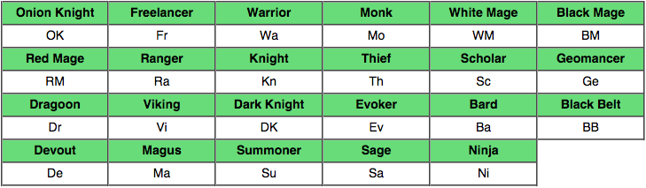



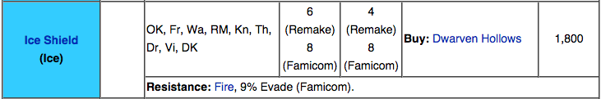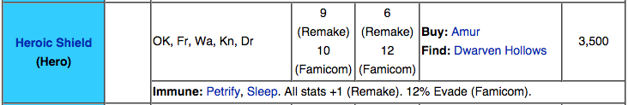

*Also immune to other things such as Confusion, Poison, Petrification and Paralyze.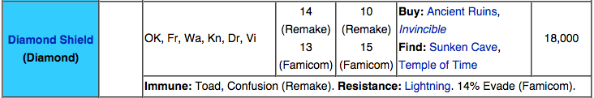 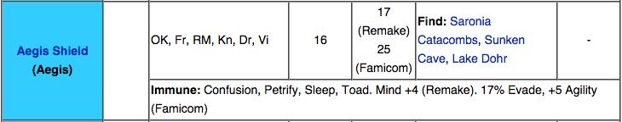

*Is immune to everything.

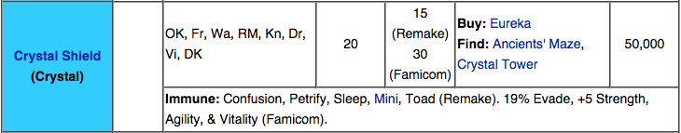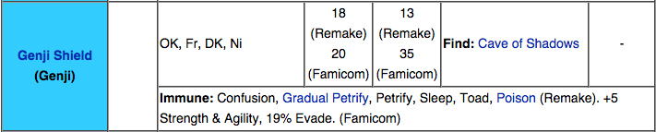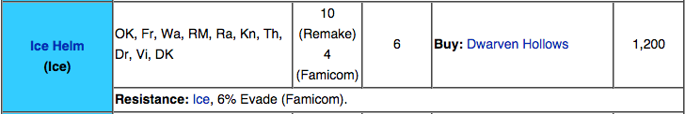*Just like the Ice Shield, the Ice Helm does not resist Ice, but Fire 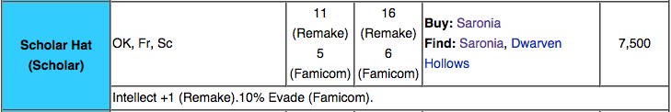 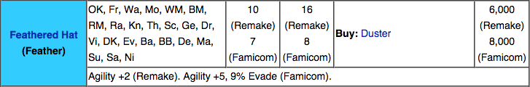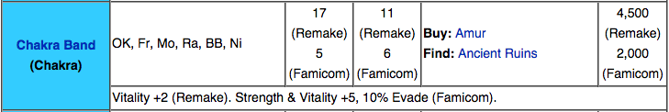 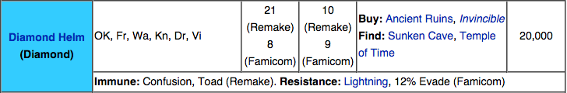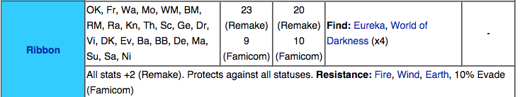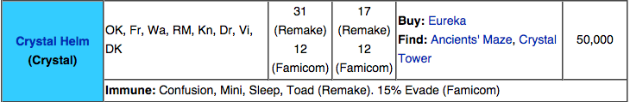 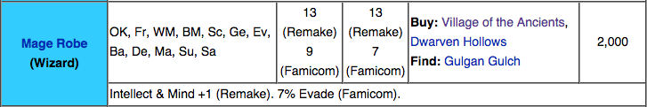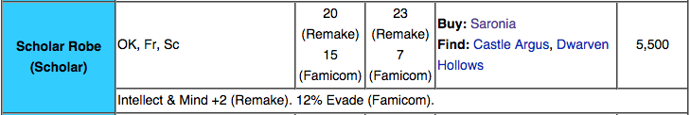 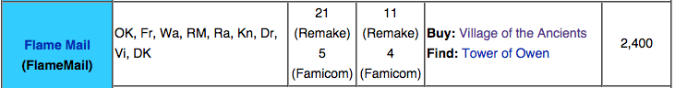*Resists Ice 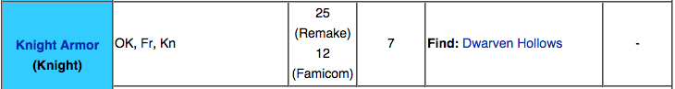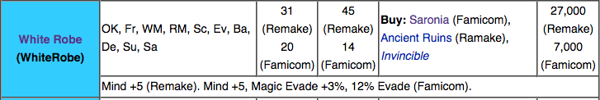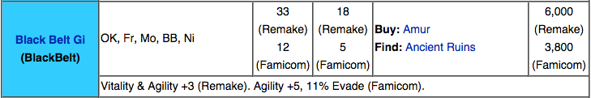 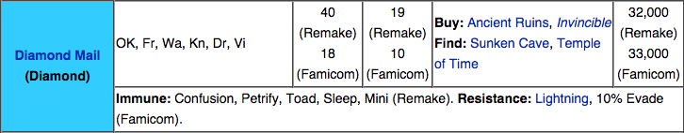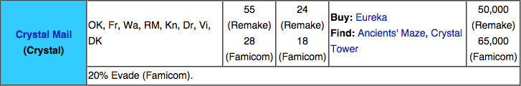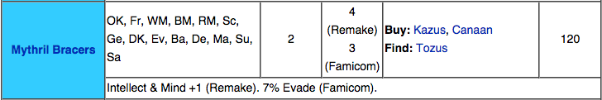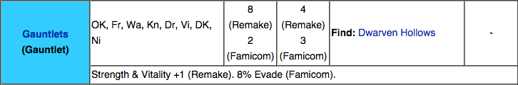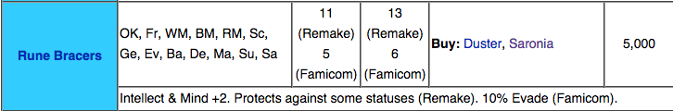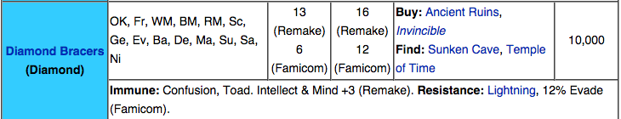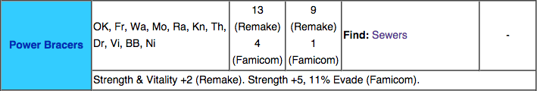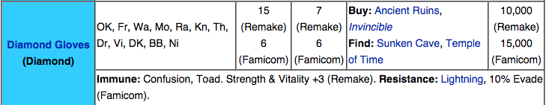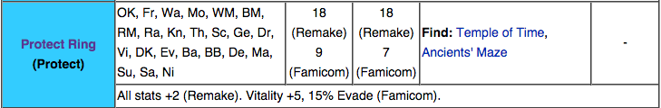*Resists every element 