English Answers – The orders of the letters are randomized. Answers have been ordered indicating how I will input them.

Class 1 - L E W M L O
ELM
LOW
OWL
OWE
WOE
WELL
MOW
MEW
MEOW
MEWL
MOLE
MOLL
MELLOW

Class 2 - H S G F T I
IFS
ITS
HIS
HIT
HITS
THIS
FIT
FITS
FIG
FIGS
FIGHT
FIGHTS
FISH
FIST
GIFT
GIFTS
GIST
SIT
SIFT
SHIFT
SIGH
SIGHT

Class 3 - S L E M S I
ELM
ELMS
ISLE
ISLES
LEI
LEIS
LESS
LIE
LIES
LIME
LIMES
MIL
MILE
MILES
MISE
MISS
MESS
SEMI
SEISM
SLIM
SLIMS
SLIME
SLIMES
SMILE
SMILES

Class 4 - R A N Y C O
ANY
ARC
ACORN
COY
CAY
CAN
CYAN
CAR
CARNY
CON
CONY
CORN
CORNY
CRY
CRAN
CRONY
CRAYON
NOR
NAY
NARY
NARC
OAR
ORCA
RAN
ROAN
RYA
RAY
RACY
RAYON
YON
YARN
Class 5 - G A E D R G
AGE
AGED
AGGER
ARE
EAR
ERA
ERG
EGG
EGAD
RED
READ
RAD
RAG
RAGE
RAGED
RAGGED
GAD
GAG
GAR
GAGE
GAGER
GEAR
GRAD
GRADE
DARE
DEAR
DRAG
DREG
DAG
DAGGER

Shop Answers for PC Version: Legend: CW = clockwise rotation of mouse. AC = anti-clockwise rotation of mouse. S = back button, W = forward button, A = left button, D = right button
Level 1 – CW, S, AC. Class 2 - CW, A, S, AC. Class 3 - CW, S, CW, A, AC. Class 4 - AW, S, CW, A, D, CW. Class 5 - D, W, CW, S, AC, A, D, AC.

Photography Instructions:
Level 1: Take pictures of these points around the school: 1. Above the main entrance of the school building. 2. On the inside of the archway to the girls dorm. 3. Over the doorway to Shop Class. 4. On the dome on top of Harrington House (Prep Dorm). 5. Over the main entrance to the Library
Level 2: Take pictures of any 3 pictures to unlock yearbook. Note: student photos do not get added to yearbook
Level 3: Take pictures of any 4 hobos or dogs
Level 4: Take these pictures of these places: 1. Bullworth Dam 2. The Main School Building 3. The Carnival 4. The Lighthouse 5. Bullworth Church
Level 5: Take these pictures at the carnival: 1. The Skeleton Man 2. The Siamese Twins 3. The Fat, Bearded Lady 4. The Midget Wrestlers 5. The Insane Painted Man 6. The Mermaid

Math Answers: Note: I’ll fill in the missing fields as I do the classes.

Class 1:
Question | Answer | Location of Answer
3 + 4 = | 7 | Middle
50 = | 4 + 45 | Bottom
6 x 6 | 36 | Bottom
How Many Triangles? | 2 | Bottom Right
Smallest? | Fly | Bottom
12 = | 20 - 8 | Bottom
Biggest? | Saturn | Bottom
Lowest? | 203 | Middle
8 + 3 = | 11 | Bottom Left
½ = | 0.5 | Top
Slowest? | Sloth | Bottom
120 = | 3 x 40 | Bottom
7 - 5 = | 2 | Top Left
Fastest? | Truck | Middle
99 = | 11 x 9 | Bottom
12 + ? = 21 | 9 | Bottom Left
35 = | 7 x 5 | Middle
Fastest? | Rocket | Top Left
How Many Squares? | 5 | Middle
0.5 x 34 = | 17 | Middle
15 - 6 = | 9 | Top Left
Fastest? | Race Car | Bottom
0.5 = | 1/2 | Middle
Tallest? | Pyramids | Middle
Highest? | 79 | Bottom Left
7 + 3 = | 10 | Top
24 = | 12 x 2 | Bottom Right
Minimum Correct Answers to Pass: ?
Fastest Combination: ?

Class 2:
Question | Answer | Location of Answer
Smallest? | Watermelon
Fastest? | Sloth
How Many Triangles? | 3
1500 = | 30 x 50
18 - ? = 5 | 13
Tallest? | Eiffel Tower
100 = | 25 x 4
2 = | 9 – 7
Biggest? | Cathedral
Highest? | 771
Shortest? | Bird House
Slowest? | Turtle
¼ = | 0.25
8 + 2 = | 10
How Many Triangles? | 2
144 = | 12 x 12
Shortest? | Bird House
55 = | 1 x 55
13 - ? = 5 | 8
How Many Triangles? | 6
Fastest? | Plane
0.75 = | ¾
15 = | 3 x 5
Lowest? | 677
Biggest? | Truck
Minimum Correct Answers to Pass: ?
Fastest Combination: ?

Class 3:
Question | Answer | Location of Answer
1kg = | 1000g
36 = | 6 x 6
Tallest? | Cathedral
0.5 = | ½
360 = | 180 x 2
Smallest? | Pizza
Slowest? | Snail
16 + 10 = | 26
2 + 9 = | 11
400 = | 20 x 20
Smallest? | Snail
Biggest? | Saturn
10 – 10 + 7 = | 7
Lowest? | 2234
6 + 5 = | 11
How Many Triangles? | 7
6/18 = | 1/3
1g = | 0.001kg
17 – 11 = | 6
2 + 7 + 2 = | 11
Smallest? | Whale
Fastest? | Whale
190 - ? = 30 | 160
How Many Squares? | 7
13 + 8 + 2 = | 23
Minimum Correct Answers to Pass: ?
Fastest Combination: ?

Class 4:
Question | Answer | Location of Answer
Fastest? | Plane
Lowest? | 0.09
How Many Triangles? | 7
49 = | 57 – 8
0.625kg = | 625g
How Many Circles? | 8
0 = | 0 x 125
Biggest? | Building
6 + 8 + ? = 2 | 23
Fastest? | Rocket
Shortest? | Birdhouse
15 - ? = 6 | 9
How Many Triangles? | 3
Slowest? | Turtle
How Many Squares? | 7
3000 = | 50 x 60
1 + 4 – 2 = | 3
Smallest? | Key
17 + 8 = | 25
1200 = | 20 x 60
48500g = | 48.5kg
Minimum Correct Answers to Pass: ?
Fastest Combination: ?

Class 5:
Question | Answer | Location of Answer
13 + 8 + 2 = | 23
Lowest? | 2234
Shortest? | Dog House
2 = | 9 – 7
689g = | .689kg
Squares? | 8
? + 6 = 3 + 11 | 8
Fastest? | Plane
How Many Triangles? | 4
Highest? | 33.8
255 = | 5 x 51
0.75 = | ¾
Biggest? | Bridge
Fastest? | Plane
1.25 = | 5/4
Slowest? | Pyramid
12 + 6 – 11 = | 7
3.14 = | 31.4 x .01
How Many Triangles? | 7
7 + ? + 3 = 17 | 7
Fastest? | Rocket
Shortest? | Tombstone
Biggest? | Cathedral
1/8 = | 0.125

Geograhpy Answers: Numbers indicate the order that I will dragging the flags to their appropriate location – the order matches the flag which appears on the far left.
Class 1:
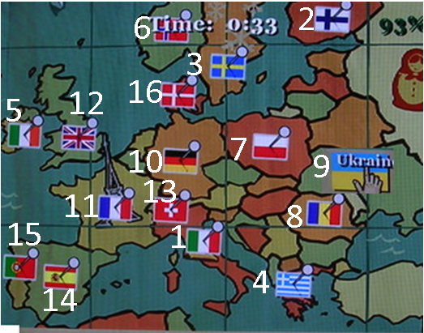

Class 2:
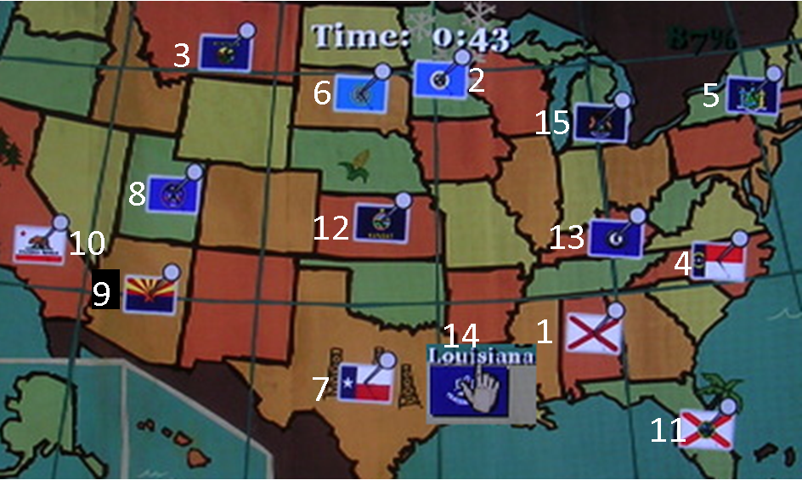

Class 3:
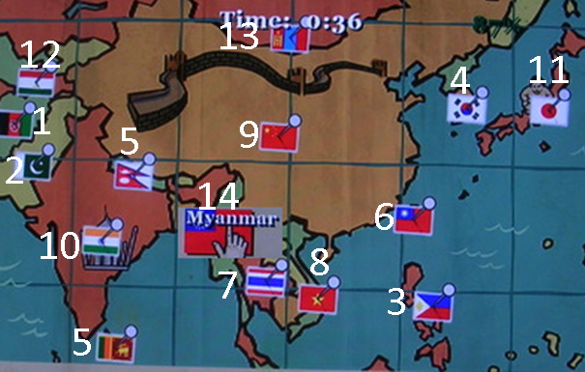
Class 4:
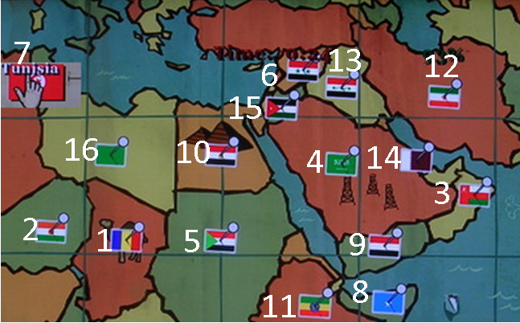

Class 5:
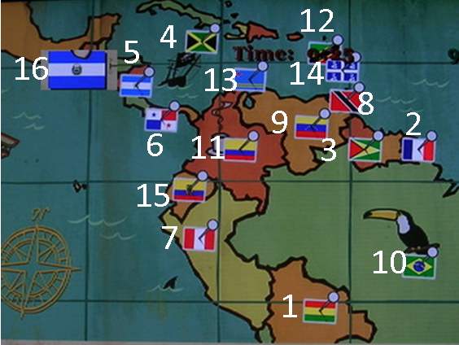

Biology: follow instructions.

Art Class: Mini-game thing

Gym 1: Wrestling 1. Gym 2: dodgeball 1. Gym 3: wrestling 2 Gym 4: dodgeball 2. Gym 5: dodgeball 3

