Donation Station Cheat Sheet (Last updated 1/2/12 by puwexil)

Select Tasks>Read Donations and Tasks>Process Bids to open the Read and Bid tabs, if they aren’t already open.

Downloading new donations from Chipin

To download new donations from ChipIn and load them into the online marathon database, select ChipIn>Merge from chipin website or press Ctrl-M. Once the merge is complete, close the merge tab (or press Esc).

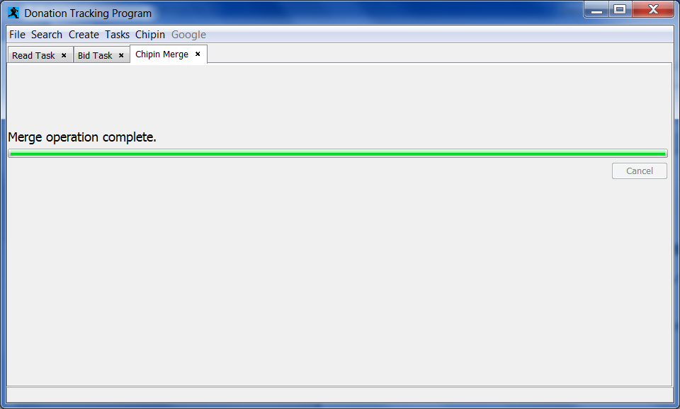

Select Refresh in the Read Donations tab (or press Ctrl-R) to display the new donations of $1 or more.
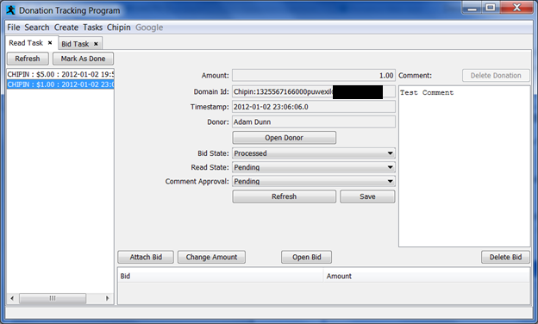

Once the donator’s name, donation amount, and comment have been read off on stream, click Mark As Done. The donation will then clear from the Read list at next Refresh.

Processing donation bids

During periods where donation comments are not being read, refresh the Process Bids tab (Select Refresh or press Ctrl-R) and update bid totals as follows:

For donation comment did not include a bid towards a Challenge (ie weaponless Contra) or Choice (ie naming a save file or RPG character), go to the Bid Task tab and mark the donation as Done.

If the comment included a bid towards a Challenge or Choice, click on the donation and then click Attach Bid.

Click the checkbox next to Speed Run, then Browse. Use the Find Run search window to select the appropriate run, then click Search in the main Attach Bid window to display the available Challenges/Choices.

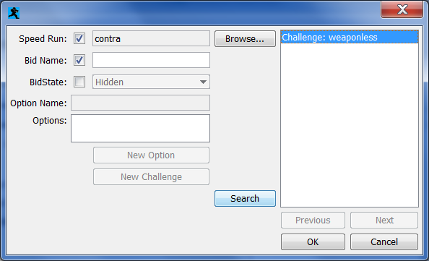

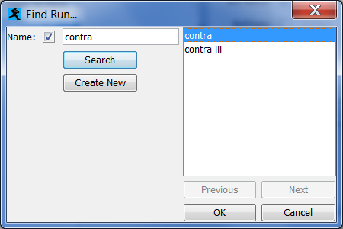

For Challenge bids, click OK once the appropriate Challenge has been selected (if donation is for a challenge not already listed, enter it into the Bid Name field and then click New Challenge to add it to the list).

For Choice bids, select the desired option in the Options area (if donation is for an option not already listed, enter it into the Option Name field and click New Option to add it to the list), and then click OK.

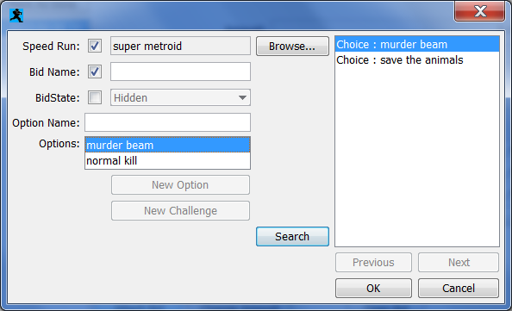

If the entire donation is to be applied towards that Challenge, just click OK in the Enter Amount window, otherwise enter in the amount of that donation to be applied, then click Attach Bid again and repeat until the entire donation amount has been assigned.

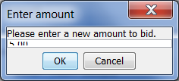

If a bid was entered incorrectly and needs to be removed, select it in the bottom of the window and then click Delete Bid.

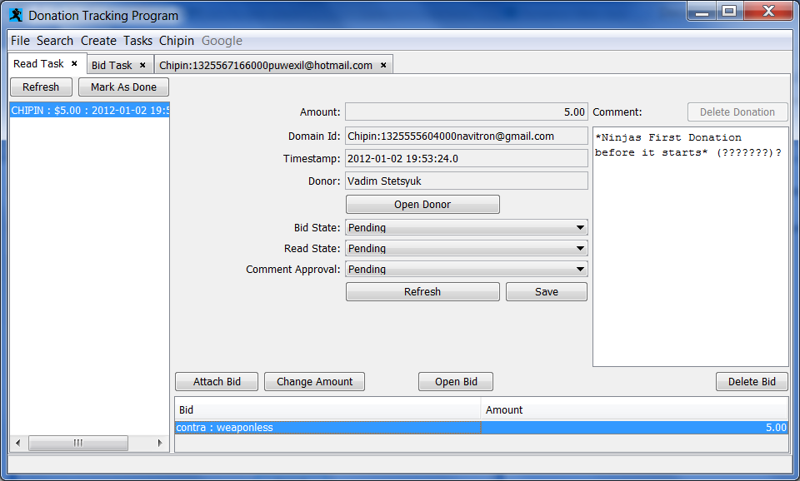

Once the donation’s bids have been processed, click Mark As Done.

If a donation’s bids need to be adjusted after it’s already been marked Done and cleared from the active donations list, select Search>Search Donation and use the search form to locate the donation, then Attach/Delete bids as needed.

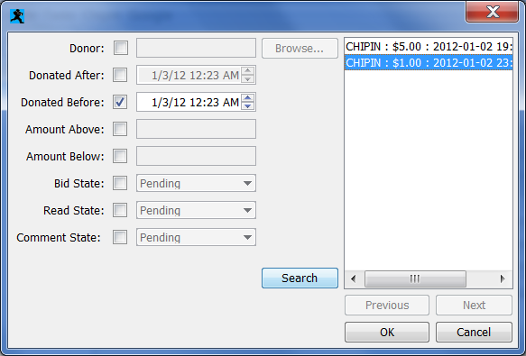

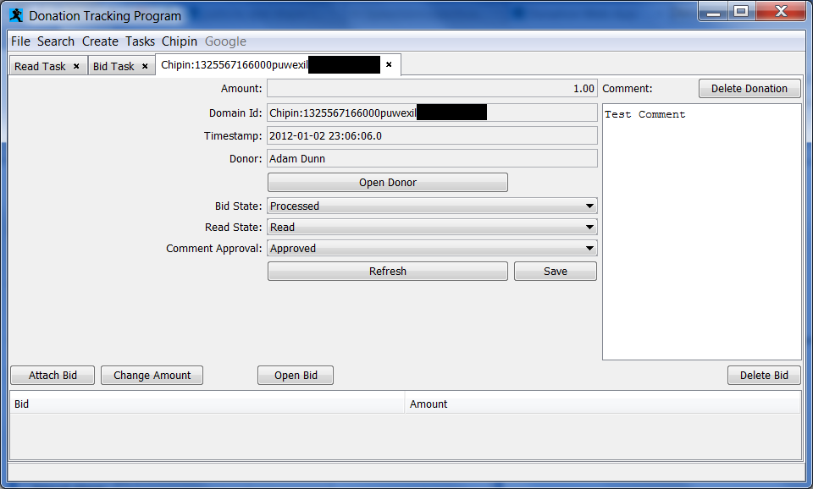

Drawing Prizes:

In order to draw a prize, you must open that prize’s tab. Either Search->Prize, and enter the name for that prize into the search field, and select the appropriate prize from the list, and hit OK.

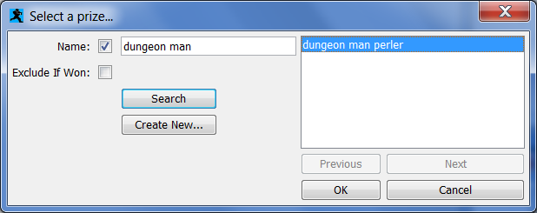

This will open a tab to manipulate this prize:

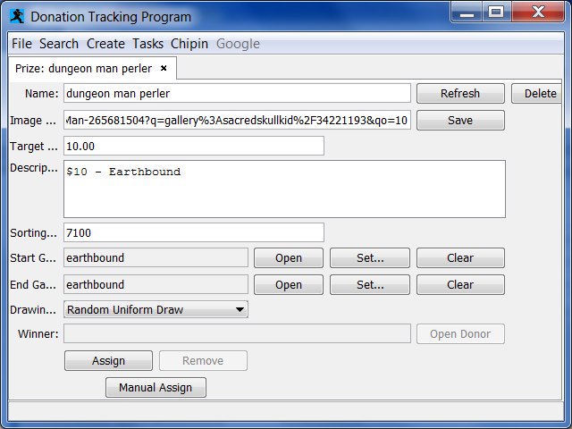

Press the ‘Assign’ button to begin drawing a prize:

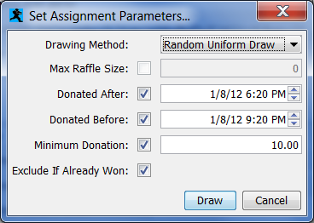

Note that the start and end-times will be auto-filled from the start and end games selected on the prize tab.
Those times in turn will be auto-filled from the google documents runs spreadsheet (see the google docs section for details).
Most prizes will not need any changes, and typically you need only hit the ‘draw’ button.

If it is successful, it will return to the prize tab with the chosen donor displayed in the ‘winner’ field. Otherwise, it will pop up an error.

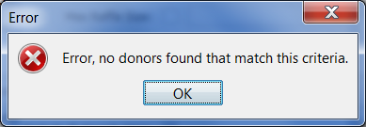

If, after assigning a winner, you need to re-draw a prize for any reason, simply press the ‘remove’ button. (DO NOT PRESS THIS FOR ANY OTHER REASON)

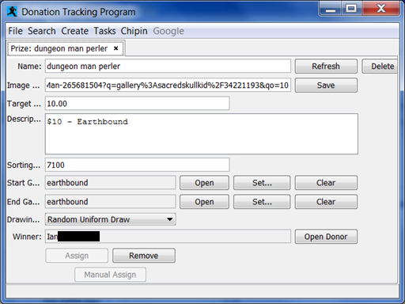

Google Docs

Every time a run is completed, someone with access to the google spreadsheet will be responsible for replacing the estimated start/end times for that game with their actual time.
To then import this data into the tracker, simply do ‘Google->Refresh Runs From Spreadsheet’. This will open a ‘Google Spreadsheet Refresh’ tab.

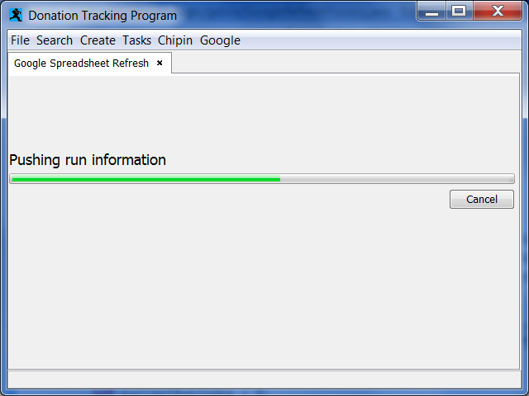
Once completed, all runs’ timing information will be up-to-date. This is useful for determining the start/end times for drawing prizes.

