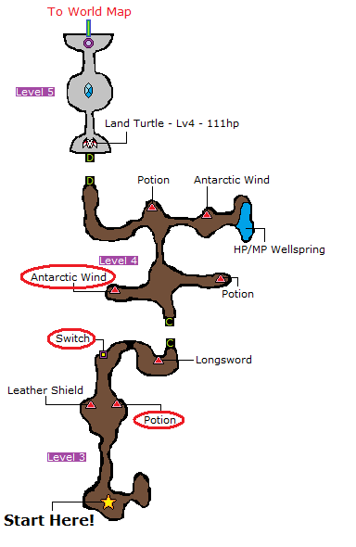

1. Pick up Potion
2. Flick the Switch
3. Get the Antarctic Wind
4. Get in the rear line and fix Config
5. Defeat the Boss
6. Enter Ur
7. Talk with the Elder
8. Give potion and get Phoenix Down
9. Find Arc
10. 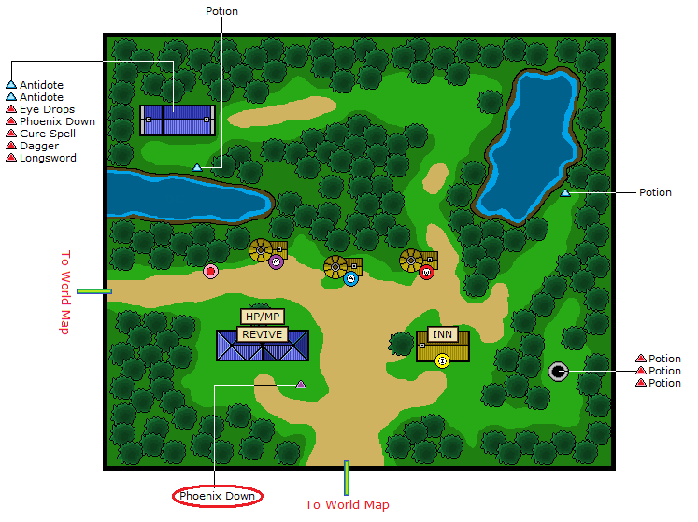Exit Town
11. Enter Kazus, Talk with Arc
12. Talk with Cid
13. Find his Airship
14. Get Ingus
15. 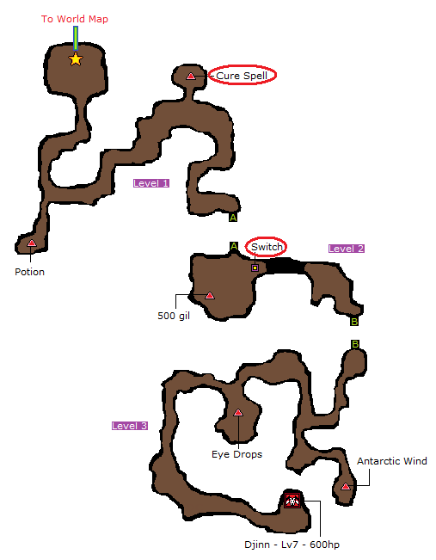Enter the Sealed Cave
16. Get the Cure Spell and Get the rest of the party in the rear line
17. Flick the Switch
18. Get Sarah
19. Defeat the Boss
20. Return to Sasune
21. Enter Kazus
22. Get Cid
23. Talk with Takka
24. (optional?) Buy Mythril Armor and Change Jobs; 4 Red Mages
25. Enter the Airship, Get Refia, Break the Rock
26. Enter Canaan
27. Talk with Salina
28. Find Mallet and Elixir (and evt. Gold Needle)
29. Enter Dreagon’s Peak
30. (evt. Pick up Golden Needle)
31. Get Desch
32. Shrink (Mallet) and enter Tozus, pick up Cura
33. Get to the Viking’s Cove
34. Talk with the Leader
35. 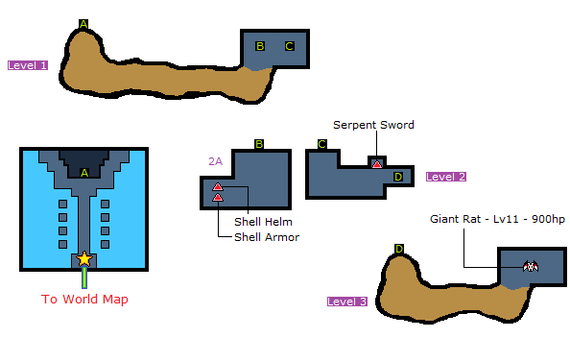Enter the Nepto Temple
36. Don’t pick up anything, lol
37. Kill the Boss
38. Exit and Place the Nepto Eye where it belongs
39. Talk with the Viking leader and get the Enterprise
40. Pick up the Lamia Scale at Tokkul (money)
41. Enter The Village Of The Ancients
42. Buy Teleport and Cura
43. Buy Best Armor available
44. Leave and Get a Chocobo
45. Go in the Boat and go into Argus Castle
46. Pick up Arctic Wind and leave
47. Talk with Gulgan at Gulgan Gulch
48. Enter the Tower of Owen
49. Use Toad x2
50. (Evt. pick up Echo Herbs at 2nd floor)
51. 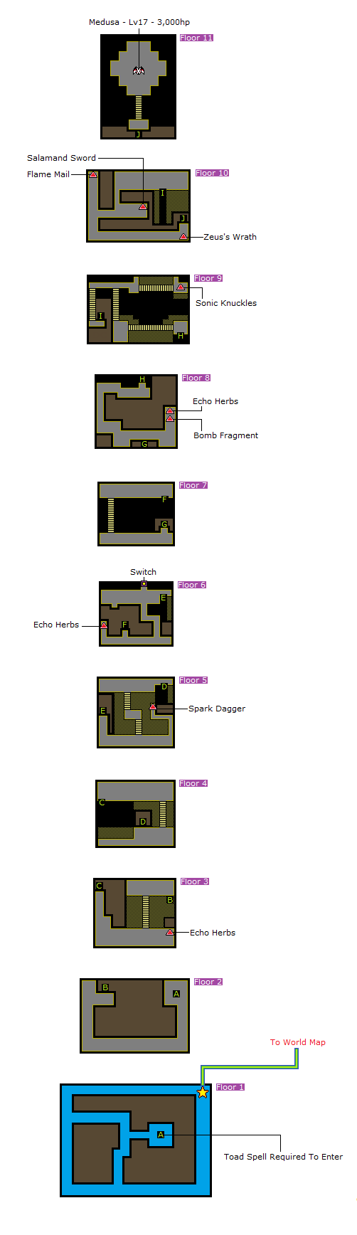Don’t Pick up anything
52. Flee from most battles
53. Defeat the Boss
54. Enter Dwarven Hollows
55. Buy Armor (?)
56. Talk with the Leader
57. Use Toad and enter the Subterranean Lake

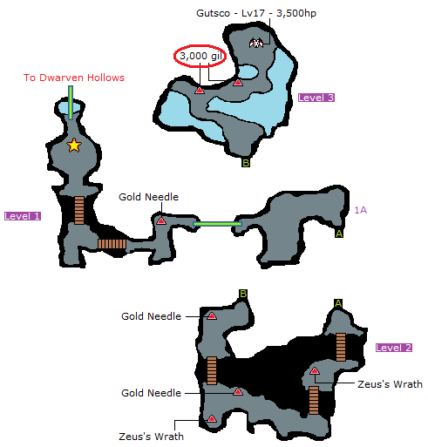

1. Pick up 3,000 Gil x2
2. Defeat the Boss
3. Teleport out
4. Get back into the Dwarven Hollows
5. Put the Fang of Ice back
6. Teleport out
7. Enter the Molten Cave
8. Don’t pick anything up
9. Flick the Switch
10. Kill the Boss
11. Get out
12. Place the Fangs of Ice back

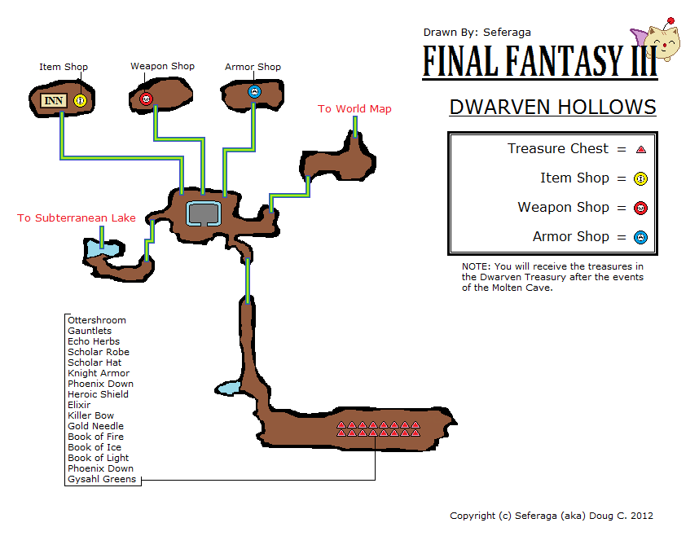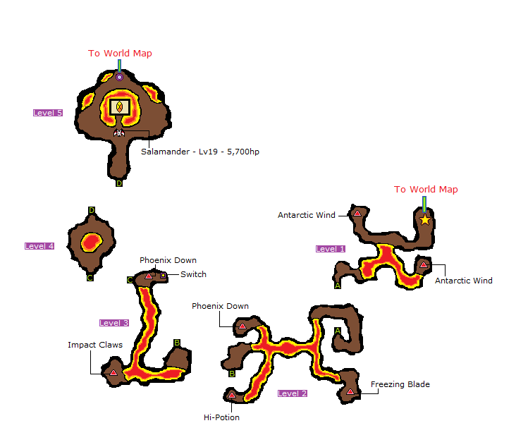

1. Pick up Ottershroom, Gauntless, Scholar Robe, Scholar Hat and Heroic Shield
2. Leave and og to Tokkul and get to Hein’s Castle
3. 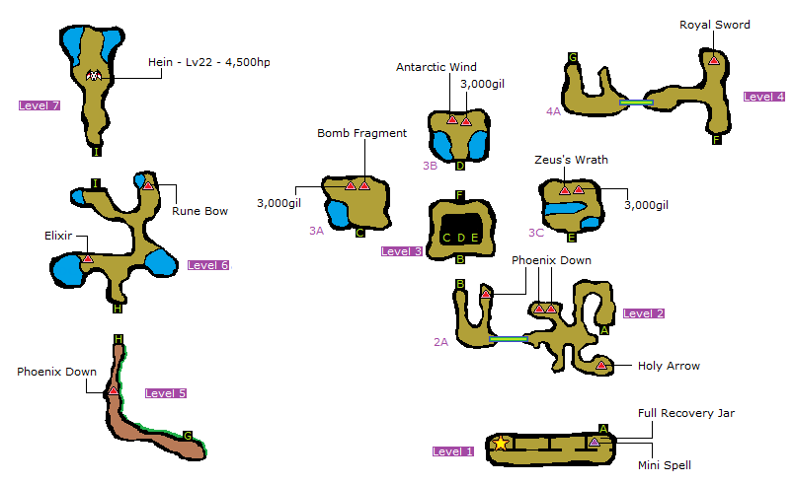Get 3 Schoolars and Use Mini with your remaining Red Mage
4. Flee from every battle
5. Beat the boss, like a boss
6. gtfo
7. Argus Castle, get the Wheel of Time
8. Go to Canaan and talk to Cid
9. Leave the Floating Continent
10. Enter the wrecked Ship
11. Wake up Aria (Antidote or Elixir)
12. Go to the Water Temple
13. Pick up the Water Shard
14. Remove the Seal in the Cave of Tides
15. Defeat the Boss
16. You’re now in Amur

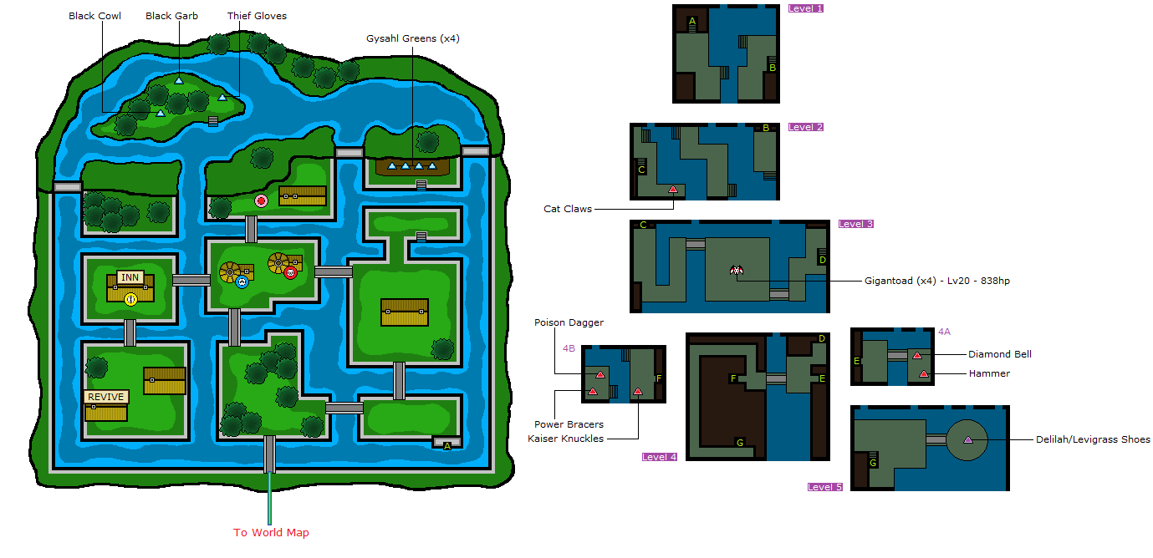

1. 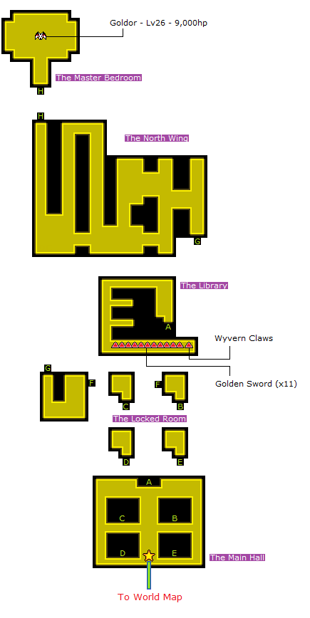Buy Antidotes, Eye Drops and Gold Needles
2. Talk with Woman
3. Talk with Gill
4. Enter the Sewers
5. Fight the 4 Gigantoads
6. Find Delilah and Leave
7. Enter Goldor’s Manor
8. Use Magic Key and Enter ”B”
9. Beat the Boss /w a Knight
10. Pick up Key
11. Teleport out (or Ottershroom)
12. Free your ship
13. Go to Duster
14. Pick up Earthen Drums
15. Buy 2 Bard Vests, 2 Feathered Hats, 3 Rune Bracers, Lamia Harp and Madhura Harp and Leave
16. Go to Saronia
17. Go to Upper-Left Saronia
18. Get Alus, save, Defeat the Boss
19. Get a new Airship
20. Go to Doga’s Manor
21. Buy Curaga
22. Use Mini and enter Cave of the Circle
23. Go to the Temple of Time (Grind with Earthen Drums)
24. Get a Thief in your front
25. Get to floor 4 and pick up the Protect Ring and the Lamia Harp
26. Get Noah’s Lute
27. Get out
28. Wake up Unei
29. Go to The Ancient Ruins

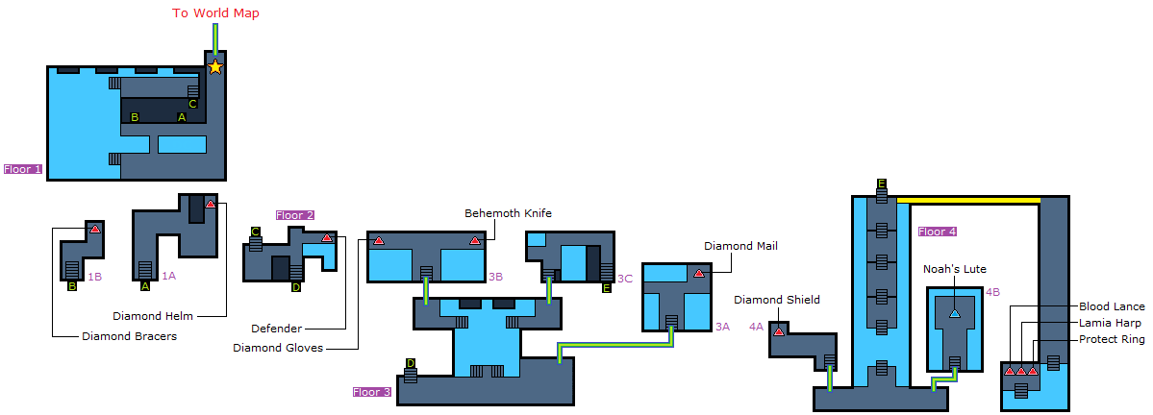

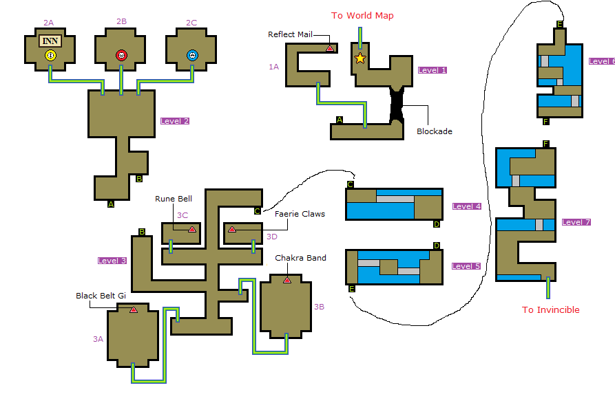

1. Get past the Blockade
2. Find the Invincible
3. Buy Ottershroom, Curaja (Armor?)
4. ~~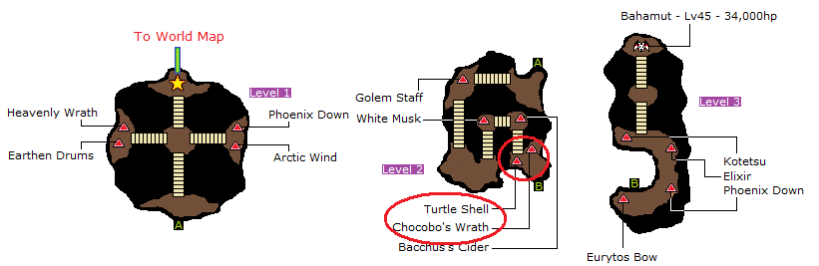Go to Bahamuth’s Lair and pick up Chocobo’s Wrath and Turtle Shell~~ (Don’t, It’s slow)
5. ~~Return to the Surface World and~~ go to the Cave of Shadows
6. 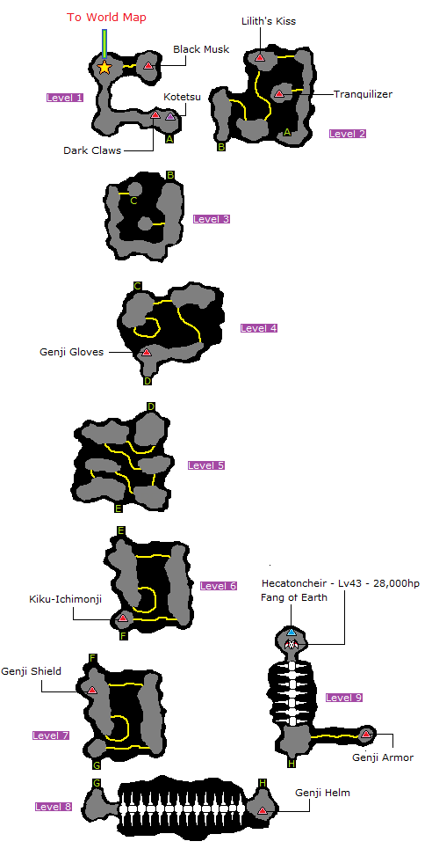Pick up Lilith’s Kiss
7. Beat the boss
8. Teleport / Ottershroom out
9. Go to Doga’s Manor
10. Enter Doga’s Grotto
11. Pick up 20,000 Gil
12. Defeat Doga and Unei
13. Get the 2 Keys
14. Teleport / Ottershroom out
15. Get past the 4 Statues
16. Enter the Ancient’s Maze

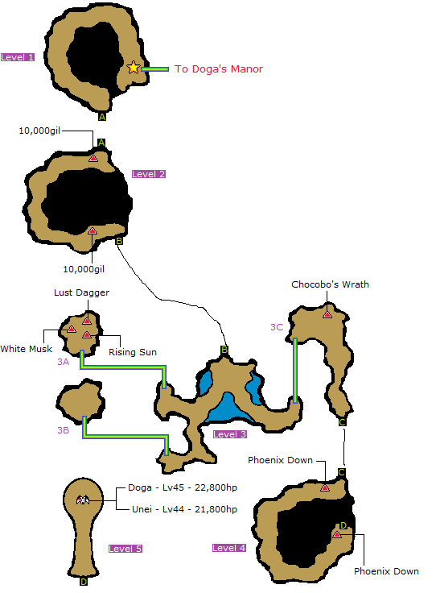

1. 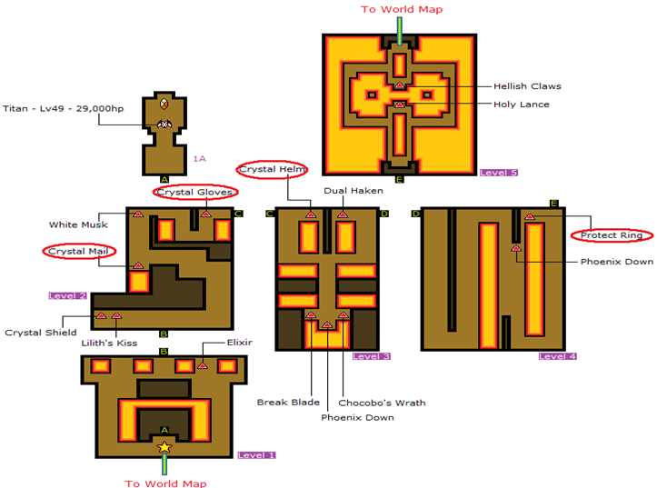Pick up Crystal Mail, Gloves and Helm (not the Shield) and Protect Ring
2. Kill most Enemies (Flee from King Behemoth)
3. Enter the Crystal Tower and go to the Forbidden Land, Eureka
4. Pick up Ribbon
5. Pick up 1 Shuriken at Level 2 and 2 Shurikens at Level 8
6. Use the HP/MP Wellspring
7. Sell Shurikens and more, and Buy Apollo Harp and a Crystal Shield
8. Teleport / Ottershroom out and **Save**
9. Enter the Crystal Tower
10. Defeat most enemies
11. No useful treasures
12. Defeat Xande; Bard, Schoolar, Schoolar, White Mage/Devout
13. Lose to CoD quickly
14. Enter the World of Darkness

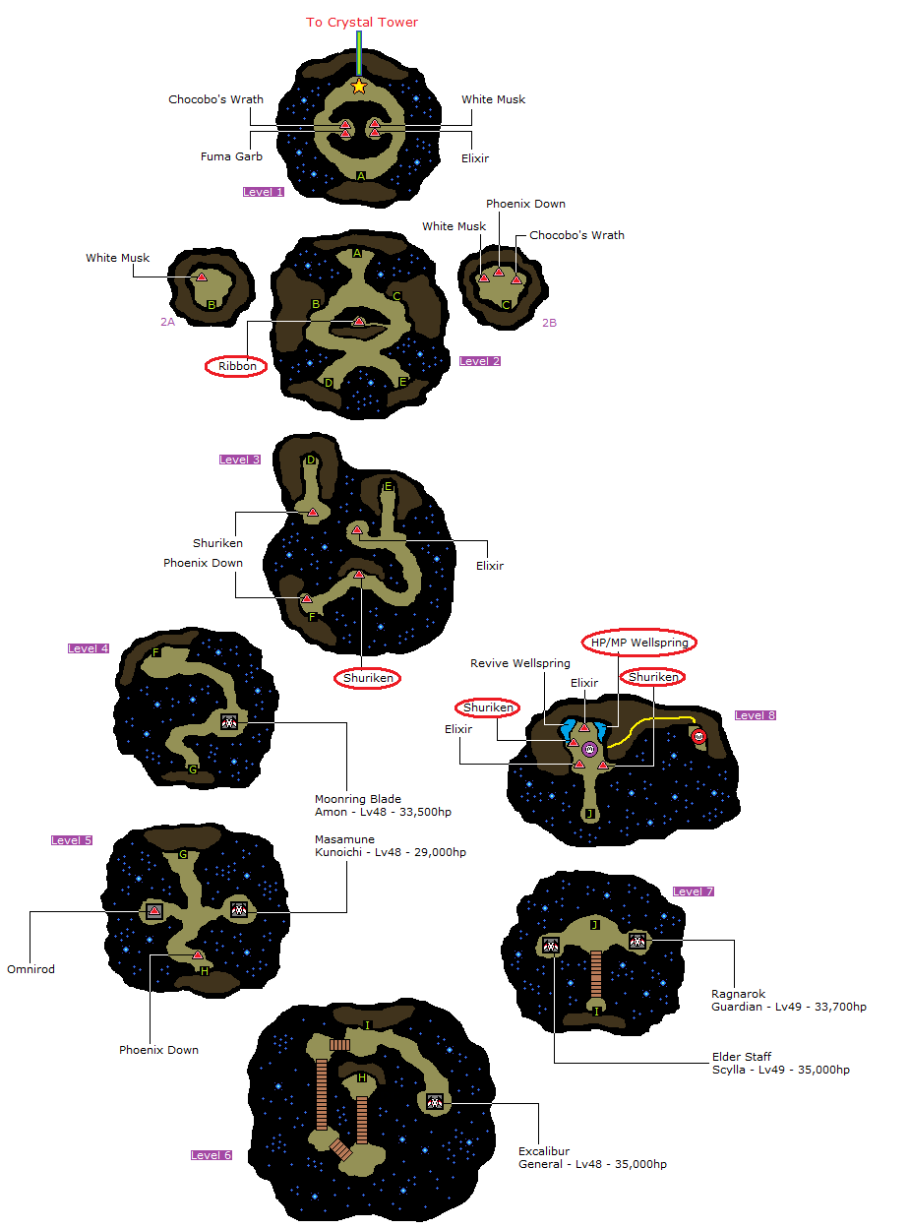

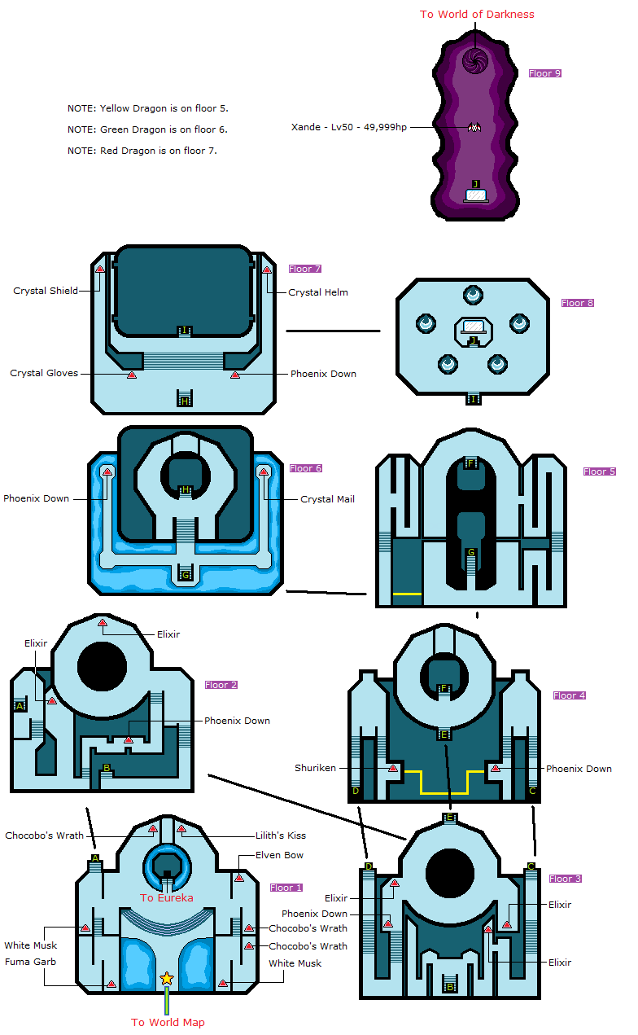

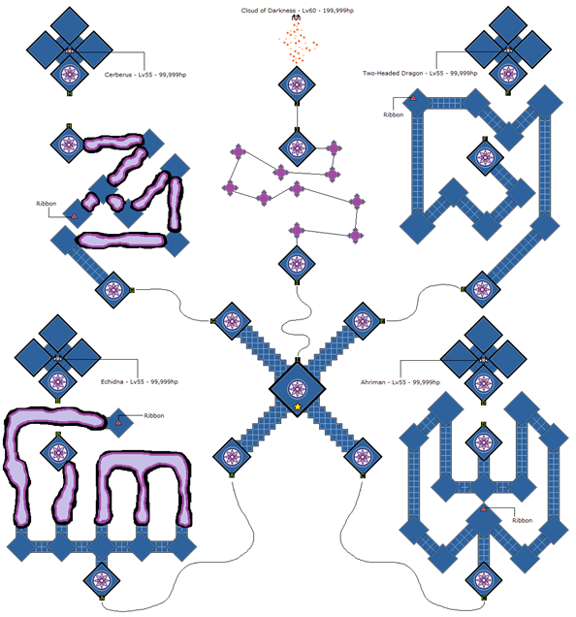

1. Go to the Cerberus place and pick up the Ribbon
2. Leave, go right and pick up the Ribbon in there
3. Defeat **Two-Headed Dragon**; Knight, Bard, Schoolar, Schoolar
4. Pick up the Ribbon and…
5. Defeat **Ahriman**; Bard, Schoolar, Schoolar, White Mage / Devout
6. Defeat **Echidna**; Bard, Schoolar, Schoolar, White Mage /Devout
7. Defeat **Cerberus**; Bard, Bard, Schoolar, White Mage / Devout
8. Defeat the **Cloud of Darkness**; Bard, Bard, Schoolar, White Mage / Devout
9. Save for new WR ?